National Cheng Kung University

Institute of International Management

Mid-term Report

Students:

Wanitsara Amphon (Sara) RA6117373
Pei-Hsuan Lu (Betty) RA7091025

1. Introduction

Service is distinguished from other products by its unique characteristics of intangibility, heterogeneity, and inseparability (Parasuraman et al., 1985). This means that what can be used to assess the performance of other products may not be as effective in assessing service performance. As a result, it is critical for service providers to have a specific measurement for assessing service performance.

With the challenge of assessing service quality, our group is interested in the hospitality industry or hotels in particular, where great effort is required to make the customer satisfied as it provides the services for a longer period of time than other service providers, such as airlines or restaurants. It can be as short as a night, however, it can also potentially last for a week or more. As a result, maintaining the level of customer satisfaction is extremely difficult for the hotel. To be more specific, in this paper, we are interested in five-star hotels because the customer would expect better services than other customers in lower classes. In reality, customers behave differently in different types of hotels. According to Zhang et al. (2011), and customers in luxury hotels prioritize location and service quality over monetary value.

Listening to what customers think is one way to learn how satisfied or dissatisfied they are with the services provided. Listening to customers through marketing research is an important method for understanding more about the target and what they expect from the services provided by the companies, giving the company the opportunity to assess and improve their service quality.

We chose the Shangri-La Hotel as our case study for this paper. Shangri-la is a five-star luxury hotel with an outstanding international reputation. They offer hotel services all over the world. Because it is located close to our campus, we are familiar with the Shangri-la Far Eastern Tainan hotel. Undoubtly, Shangri-la Tainan is one of tourists’ best choices for spending their time in this city, with over 9,000 reviews on Google Maps.

In this paper we adopt two methods that we have evaluated as appropriate for the hotel in order to collect more data about customer satisfaction, assess, and improve service quality. The first method is known as critical incident technique (CIT). CIT has been used for over 60 years and has been modified to perform a variety of functions in a various industries. We choose to collect data through an online platform for this method. The other method is Exits Surveys or Post Transaction Surveys. To cover all aspects, this method will collect data from the offline channel by soliciting feedback directly from hotel guests who are staying or checking out.

2. Critical Incident Technique (CIT)

The Critical Incident Technique is a method of conducting customer research that captures descriptive stories about a given experience (Kim and Lehto, 2012). The researcher will analyze the attribute level by classifying events into different categories after provoking the interviewee's memory by asking them to explain an event they can remember. In other words, CIT is applied as a tool to identify the key quality dimensions to be used as criteria to generate and evaluate strategies. The term "critical incident" refers to events that significantly deviate from the service's customers' expectations. Thus, not all service incidents were classified, critical incidents are frequently memorable for customers because they can be significantly positive or negative.

We choose CIT because it is a flexible method which frameworks or hypotheses are not the requirement. Furthermore, CIT has been used in a variety of industries for over 60 years and is still widely used today. As a result, it is appropriate to use CIT as one method of listening to customers. To illustrate, Gerson Tontini (2017), Lu and Stepchenkova (2012), and Xu and Li (2013) have all used CIT as a research method for hotels. As a result of our interest in the service quality method for Shangri-la Far Eastern hotel, it is compelling to use CIT as our research method due to its flexibility in classification. This is hugely advantageous to the hotel industry because these classifications would assist managers and employees in determining which aspects of the service need to be improved.
2.1 Data collection
Initially, traditional CIT method with real interviews were used to get customers to tell their experience stories. However, in this paper, we propose the CIT method by utilizing data from an online platform. People nowadays use eWOM to share their stories or experiences with their connections via their social media accounts, or the traveling review websites, such as Booking.com and TripAdvisor. Surprisingly, millions of travelers are increasingly relying on online opinions or reviews when booking hotels. For example, 60% of US travelers consider online reviews when making career decisions (Casaló et al., 2015). Essentially, travelers have begun to place a high value on online opinions, and they now regard them as more useful than other online sources of information (Casaló et al., 2015). We can see that what people say online or through eWOM can influence the decisions of potential customers. Furthermore, Öğüt and Onur Taş (2012, p. 210) discovered that a 1% increase in online customers can effectively increase sales by up to 2.68%. Interestingly, Zhang et al. (2016) found that travelers are giving more weight to negative information when forming judgements and making decisions. Travelers spread negative opinions when they encounter service failures or when real situations fail to meet their expectations. Thus, it is recommended to maintain the positive stories on the platform by identifying the factors that influence customer satisfaction, causing them to recommend the hotel via eWOM.

To determine which platform would be the reliable source of data. We finalize the choices to Booking.com and TripAdvisor. We monitored and sampled comments on both websites. There are 1,000 TripAdvisor reviews and over 3,000 reviews on Booking.com for Shangri-la Far Eastern Tainan. We then examined the specific content in the comment. We discovered that the prompt from Booking.com, which asked customers to provide both positive and negative experiences with the hotel, broadens our samples and makes the Critical Incident Technique easier to apply. Furthermore, only customers who book the hotel through their platform can leave reviews online, implying that the reviews are genuine. Therefore, Booking.com is selected to be our source of data collection.

Picture 1 The elements of customers’ review on Booking.com
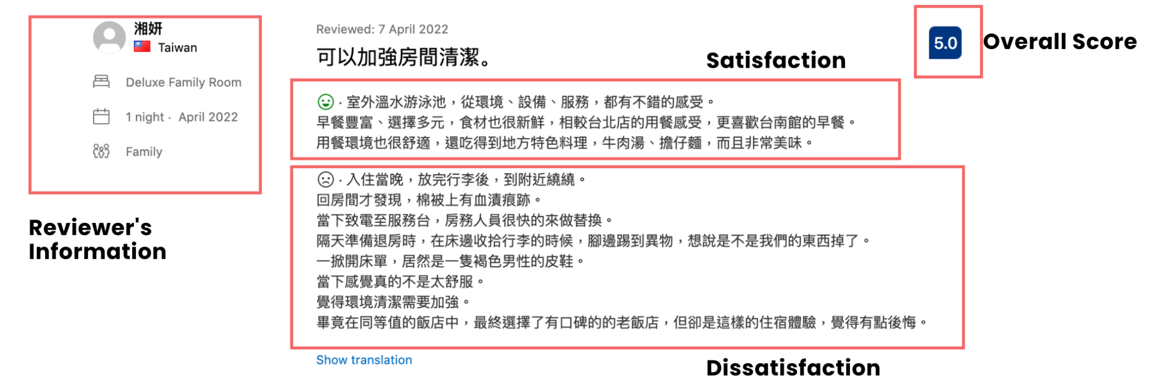

The data was collected in November 2022. The reviews were part of the sample. We only use Shangri-la Far Eastern in Tainan to reduce the variance of expectations with the hotels, as well as motives for the city and the trip itself. We obtained 1,180 reviews of this hotel on Booking.com from November 1st 2021 to November 30th 2022, and we eliminated the reviews with no comment and those not qualified to be critical incent (too neutral), yielding a total of 226 reviews. Following that, we analyzed the comments in selected reviews, identified and categorized them as satisfied or dissatisfied. If a review contained both positive and negative comments, both were extracted and categorized.

According to Gremler (2004) review, studies using the CIT method classify events in three ways: (1) primarily analyzing data in an interpretive manner with no previously defined categories; (2) using content analytic methods with previously defined categories; or (3) combining CIT with another research method. In this paper, we employ the most common method, which is employing predefined critical aspects from Tontini et al. (2017). Tontini’s method are 25 major dimensions of the hotel service performance. However, after we have collected the data and analyze it into given dimension, some dimensions are not mentioned in the data, and some data cannot be classified into any of the 25 dimensions. This could be due to the previous study, in which they studied in a different hotel class and were unable to fully describe all of the aspects that five-star hotel customers desired. With CIT's flexibility, we modified our approaches to our case study into 20 dimensions that specifically influence Shangri-la Tainan guests' satisfaction, with the addition of view, room amenities, and room maintenance.
2.3 Result and discussion
In the first stage, we classified hotel service attributes in terms of satisfiers and dissatisfiers. Interestingly there were more comments related to satisfaction than there were to dissatisfaction.

Table 1 Research Finding using CIT
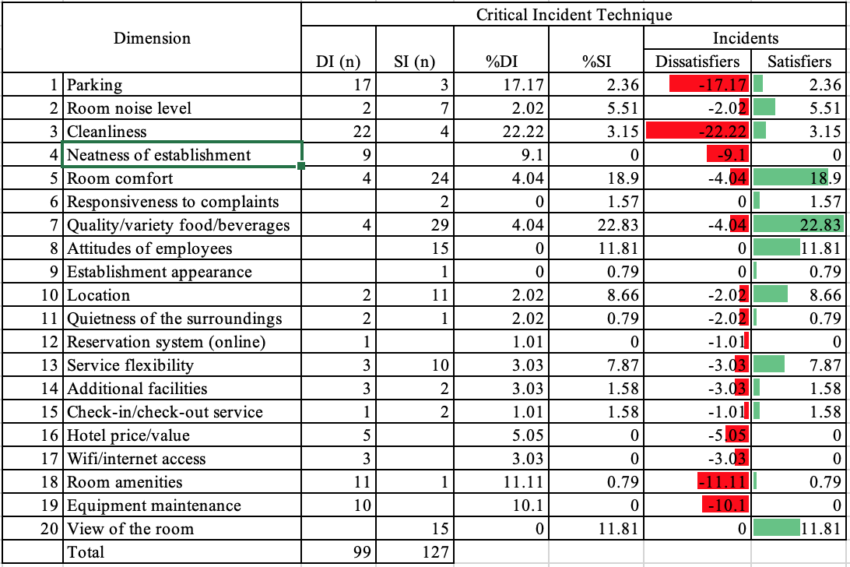

Looking at the table of result, we see that the most frequently mentioned and significant sources of satisfaction are the room comfort, quality of food, attitude of the employees and view, accounting for more than 65% of satisfaction incidents. Following these factors are location and service flexibility. In the data we have collected, the customers satisfy the food because of the variety and quality of the breakfast, which provides in international theme, the customers can choose the dishes from several nations. As for the comfort, most of the comments describe that the space in the rooms is spacious, bed was clean and comfortable. Customers also describe that the employees were friendly and enthusiastically tried to help them when they were in need. And Lastly the view, they satisfy that they can see the scenic view from their room’s window and that make their stays memorable.
On the other hand, looking at dissatisfier factors, the present study identifies cleanliness, parking, room amenities, room maintenance. These factors account for more than 60% of the total dissatisfying incidents. With the data we have collected the major source of dissatisfaction comes from the cleanliness of the room. The examples of the complaint regard to this dimension are that the floor was slippery, or the smell of the room was not desirable or they found the bathtub was not cleaned properly. Another critical dimension is the parking, which the guest complained due to the shared parking with the department store. Due to the room amenities dimension, the guest dissatisfies because they were not provide enough of the essential product in the room. For example the tissue paper, which is provided only in the bathroom, but not in the living space.

From the table and the data we have extracted from the online reviews, these help manager know that which dimension of the service that the hotel are good at doing, the manager can reward the employees responsible in that field. In contrast, the dimensions with regard to the dissatisfaction, this result also helps manager to give more attention to correct the low performance of the service in that particular dimensions. These can be done by checking the performance more often, or giving the additional training to the employees.

2.4 Strength and weakness

2.4.1 Strength
To begin, CIT enables customers to tell their own stories about their experiences in their own words. This means that the hotel will be able to understand the customer's thoughts without bias. And without a framework, there is no way to frame the customer response and avoid bias that may occur when they read or listen to the question. Furthermore, CIT methods provide companies with knowledge in areas where they previously had little knowledge. CIT results would aid in describing and explaining these phenomena (Bitner, Booms, and Tetreault 1990). As we can see from our case study, we initially had no assumptions about what makes customers happy or unhappy with the Shangri-la hotel. However, as we collected and analyzed data using the CIT method, we gained a better understanding of which aspects of the service influence customers' experiences with the hotel. More importantly, because there are no rigid rules to follow, the CIT method allows the researcher to adjust the criteria to meet the objective of the topic being studied (Burns, Williams, and Maxham 2000; Hopkinson and Hogarth-Scott 2001; Neuhaus 1996). In our case, we used the CIT criteria from Tortini's previous research (2017). However, due to differences in context, some of their categories could not be used in our study. Similarly, our data collection suggests some other aspects that customers are concerned about that were not included in the previous research, such as hotel room amenities. The majority of them studied in general hotels, but Shangri-la is a five-star hotel, so the customer's perspective may differ. CIT methods enable us to more precisely modify and fit to our research objective.

Online data collection also makes it easier to collect data in less time while collecting a larger amount of data. Booking.com, for example, has provided us with over 1,180 reviews per year, which have been sorted down to 220 incidents. As in reality, it appears to be difficult to go ask and listen to more than 200 people, and it would take time and money to obtain all of the information from the customers.

2.4.2 Weakness
To begin, recall bias is one of the potential byproducts of CIT methods (Michel 2001). The incident reported may have occurred as early as the time of checkout or as long ago as a week or month before they reported their experience. This is related to recalling a past event, and the respondent may not accurately recall a past event or experience, or may leave out details when reporting on it. The incident could be reinterpreted by the reviewer (Johnston 1995). In addition, other undesirable biases, such as consistency factors or memory lapses, may exist (Singh and Wilkes 1996) Furthermore, with the collection of online reviews, it is difficult to obtain additional information from what has been posted, and without additional details, it may be difficult to analyze what actually occurred. As evidenced by the total of 1,180 comments. Only 200 incidents can be analyzed. For example, some are simply disappointed but do not elaborate on the incident; with these uncontrollable sources of data, it is difficult for the researcher to understand why they are dissatisfied.

3. Post-transaction survey / call
According to the article “Understanding Customer Expectation and Perceptions Through Marketing Research”(Donna J. Hill 2000), the authors mentioned the method of Post-transaction survey / call is that by asking several questions they can get immediate feedback from the guests. The importance of using this listening to customer method is because we can immediately get the feedback of the guest or customer’s real feeling, and try to make up for the mistake or discomfort of the guest. In order to get the real data of customer feedback, we directly call the service manager in Shangri-La Hotels in Tainan Branch.
The questions we ask the service manager are what methods Tainan branch Shangri-La use to collect and listen to customer feedback. There are four ways that Shangri-La used to listen to their customers, which is to leave survey cards in each hotel room, face-to-face interaction with customers at the front desk, in-room call or after staying call, and also the VIP lounge service methods.

3.1 Survey card
The first and the most traditional way to listen to customer feedback is by leaving the survey card in the room, and hotel workers expect the guest will leave their stay experiences after they check out. Unfortunately, the service manager told us that this method is the most non-effective way to collect feedback. Because usually guests will reject or neglect the survey card, which causes the hotel can’t collect real data feedback from their customers. However, the Shangri-La still maintain this method because they still believe there might be a chance guests will fill out the survey card, or the guest might feel warm and caring when they see there is a survey card in the room.

3.2 Front desk Caring
The second method that Shangri-La uses to collect feedback from guests is directly asking about each customer’s experience of staying when they check out or check in. The service manager mentioned that this method is the most effective and realistic way to receive data and feelings from their customer. Even though some customers complain about the staying experience they had in Shangri-la, the front desk will immediately apologize for this bad experience and to see what they can do or provide to make the guest feel better. In contrast, some customers give compliments to Shangri-la and mention that they have great experience in this hotel. By this point, the front desk will appreciate the customer’s compliment and also see whether they want to join the Shangri-la membership, so the member can have more and better offers when they next stay.

3.3 Room Calling
The third way that Shangri-la uses to listen to their customers is through in-room calls or after-staying calls. The service manager mentioned that this is a very interesting way they collect feedback because many and most of the guests are shy or don’t know what to say when hotel workers ask about their stay experiences. Instead of directly, face-to-face telling the front desk, they prefer to call the front desk in their room or after they left the hotel to express their feeling about staying in this hotel. So in the same way, the Shangri-la only can try their best to make up for these bad experiences with guests or to offer them something beneficial for guests to feel respect and satisfaction.

3.4 VIP lounge Feedback
Last but not least, the way that Shangali-la uses to collect feedback from customers is from their VIP lounge. In Shanghai-la, the guest can choose to stay in a more luxurious room, which means they can also have access to the VIP lounge. In the VIP lounge, it offers free drinks and food, more importantly, the server will always come by and ask if there is anything they can offer for the guest. The service manager told us that the feedback from the VIP guest is different from normal guests because the VIP lounge is the highest standard of quality service that Shangali-la can arrange and provide. So, if there is a complaint about the VIP lounge, Shangri-la will need to focus on their service quality.

3.5 The Strength and Weakness of the Post-transaction survey/call method.
The strength of using the post-transaction survey is that hotel workers can immediately get feedback from customers and offer them other better services that make them feel greater experiences. Directly face-to-face talk at the front desk is the most effective way to listen to customers.
In contrast, the weakness of using the post-transaction survey is that not all the guests are willing to provide or share their feeling immediately to hotel workers because they might feel uncomfortable by telling their real staying experience in Shangri-La. Most of the guests prefer to leave comments, reviews, and messages online for another potential guests to evaluate.
(Table 1.1)

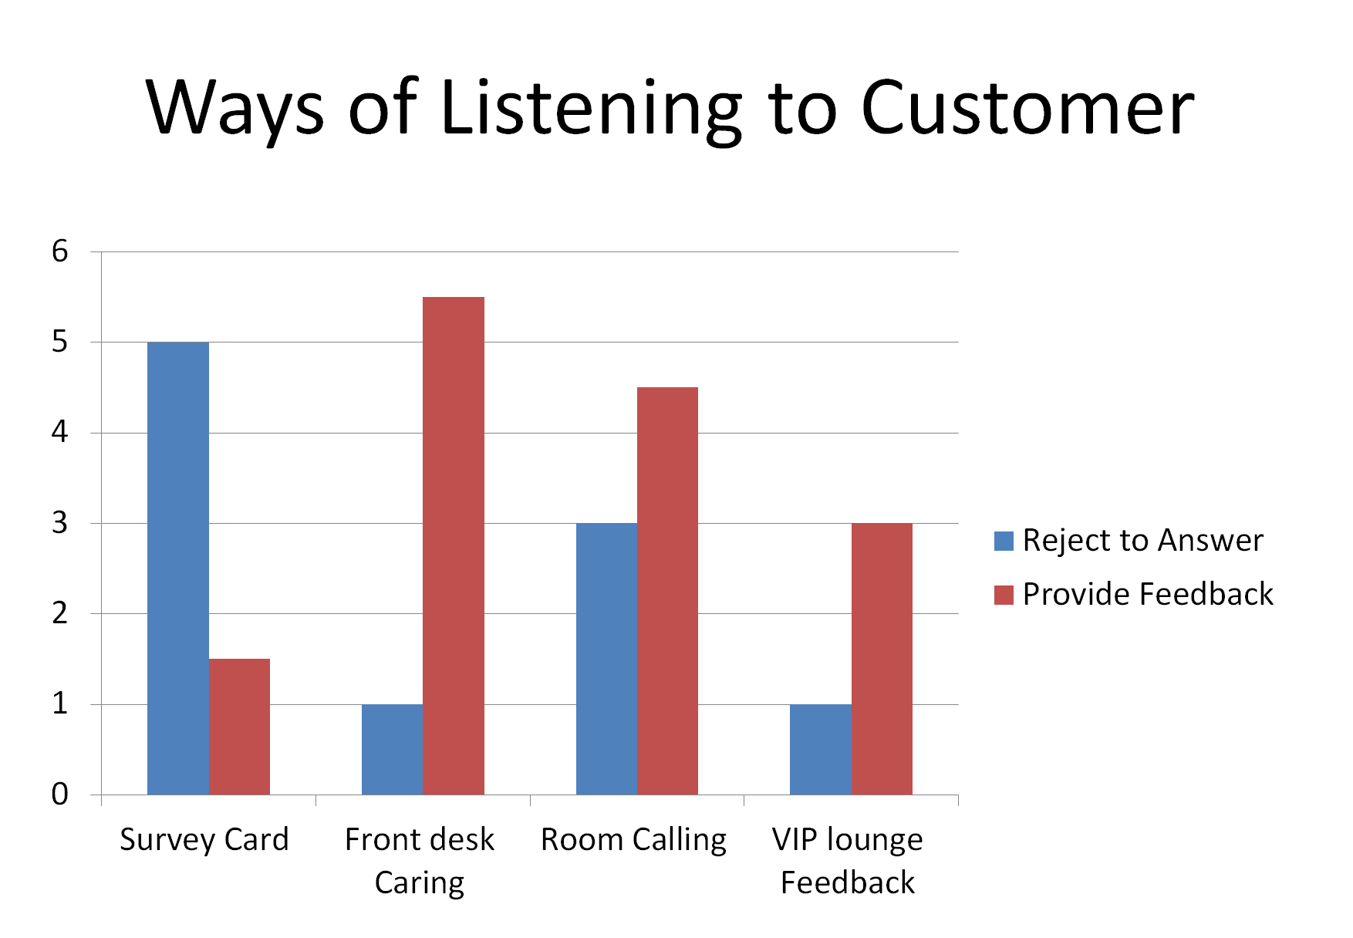
(Table 1.1) Results from the service manager in Shangali-la (Tainan branch)

4. Conclusion
We choose to use both Post-transaction survey / call and Critical Incident Technique are because by using and combining the online / offline feedback from guests. By the statistics and data we collect, this is the most effective way for Shangri-la to know which strength of service quality they should maintain and keep, and which weakness of service quality they should improve or to change to gain more customer loyalty. We recommend Shangri-La in the Tainan branch should really focus on online and offline reviews from the customer. By combining all strengths, Shangri-la might have the best service quality in Taiwan. For example, they can frequently provide the free food or drinks to promote the customer to join the membership, and further to increase the customer loyalty to Shangri-la in Tainan Branch.

References

Access Denied. (n.d.). https://www.shangri-la.com/tc/tainan/fareasternplazashangrila/
Bitner, M. J., Booms, B. H., & Tetreault, M. S. (1990). The service encounter: diagnosing favorable and unfavorable incidents. Journal of marketing, 54(1), 71-84.
Casalo, L. V., Flavian, C., Guinaliu, M., & Ekinci, Y. (2015). Do online hotel rating schemes influence booking behaviors?. International Journal of Hospitality Management, 49, 28-36.
Chen, J. (2022) Post-trade processing: Definition, how it works, and examples, Investopedia. Investopedia. Available at: https://www.investopedia.com/terms/p/post-trade-processing.asp (Accessed: December 2, 2022). \
C | Zeithaml, V. & Bitner, M. J. Service Marketing. Integrating customer focus across the firm. (Third or later edition). Chapter: Understanding customers’ expectations and perceptions through marketing research.
Gremler, D. D. (2004). The critical incident technique in service research. Journal of service research, 7(1), 65-89.
Hopkinson, G. C., & Hogarth-Scott, S. (2001). " What happened was..." broadening the agenda for storied research. Journal of Marketing Management, 17(1-2), 27-47.
Johnston, R. (1995). The determinants of service quality: satisfiers and dissatisfiers. International journal of service industry management.
Kim, S. E., & Lehto, X. Y. (2012). The voice of tourists with mobility disabilities: insights from online customer complaint websites. International journal of contemporary hospitality management.
Lu, W., & Stepchenkova, S. (2012). Ecotourism experiences reported online: Classification of satisfaction attributes. Tourism management, 33(3), 702-712.
​​Michel, S. (2001). Analyzing service failures and recoveries: a process approach. International journal of service industry management.
Öğüt, H., & Onur Taş, B. K. (2012). The influence of internet customer reviews on the online sales and prices in hotel industry. The Service Industries Journal, 32(2), 197-214.
Parasuraman, A., Zeithaml, V. A., & Berry, L. L. (1985). A conceptual model of service quality and its implications for future research. Journal of marketing, 49(4), 41-50.
Post transaction surveys. Post Transaction Telephone Surveys - Phone Surveys from DSC. (n.d.). Retrieved December 2, 2022, from http://www.survey-calls.com/survey-article-post-transaction.htm
Singh, J., & Wilkes, R. E. (1996). When consumers complain: A path analysis of the key antecedents of consumer complaint response estimates. Journal of the Academy of Marketing science, 24(4), 350-365.
Tontini, G., dos Santos Bento, G., Milbratz, T. C., Volles, B. K., & Ferrari, D. (2017). Exploring the nonlinear impact of critical incidents on customers’ general evaluation of hospitality services. International Journal of Hospitality Management, 66, 106-116.
Xu, X., & Li, Y. (2016). The antecedents of customer satisfaction and dissatisfaction toward various types of hotels: A text mining approach. International journal of hospitality management, 55, 57-69.
Zhang, Z., Ye, Q., Law, R., (2011). Determinants of hotel room price: an exploration of travelers’ hierarchy of accommodation needs. Int. J. Contem. Hosp. Manage. 23 (7), 972–981.
Zhang, Z., Zhang, Z., & Yang, Y. (2016). The power of expert identity: How website-recognized expert reviews influence travelers' online rating behavior. Tourism Management, 55, 15-24.

